Project Development Phase
Model Performance Test

Date | 10 February 2025
Team ID | LTVIP2026TMIDS76616
Project Name | HematoVision – Advanced Blood Cell Classification Using Transfer Learning
Maximum Marks

Model Performance Testing:
Project team has evaluated the trained MobileNetV2 model using training and validation datasets to measure accuracy and performance.
Project team shall fill the following information in model performance testing template.
S.No. | Parameter | Values | Screenshot
 | Model Summary | Transfer Learning using MobileNetV2 with custom classification layers (Dense + Softmax). Total Parameters: ~3.5 Million | 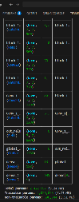  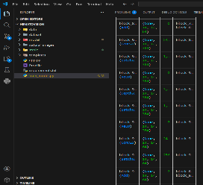
 | Accuracy | Training Accuracy – 99.38%  Validation Accuracy -88.62% | 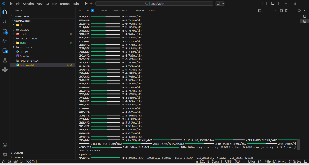
3. | Fine Tunning Result( if Done) | Validation Accuracy -88.62% | After performing fine-tuning on the MobileNetV2 base model, the validation accuracy improved to 88.62%, indicating better generalization and enhanced overall classification performance.

The MobileNetV2 transfer learning model was trained on a blood cell image dataset containing four classes: Eosinophil, Lymphocyte, Monocyte, and Neutrophil. The model achieved a training accuracy of 99.38% and a validation accuracy of 88.62%. The results demonstrate strong learning capability with improved generalization after fine-tuning

Figure: Model Accuracy Graph

